Scanner imitators

What is it?

Imitators of IM and SLM are intended for imitation of the scanner type MDL SLM Stockpile Scanner (MDA082). Even if there are no at all scanner imitators allow to organize process of debugging and testing of calculation program volume.exe and to check up its performance.
Scanner imitation is carried out by means of two imitators IM and SLM, because there are two sensors in scanner: SLM – simulates the rotating range and angle finder scanning a cross-section cut of calculation area; IM – simulates the range finder defining longitudinal position of the scanner.

Installation

The Distribution kit Java Development Kit (JDK) is needed for imitators work and one can download it by the link: http://java.sun.com/download.
Installation of imitators take place together with installation of the calculation program volume.exe when one unpacks an archive volume_installer.exe (imitators included into subdirectory java_imitators).
Run a file volume_installer.exe.
In the field «a purpose folder» choose the directory which is necessary for installation. Click the button unpack. Open a folder of installation and run one of the following executable files:
- start_GUI.bat – to run the program of management (it is recommended);
- start_console.bat – to run consol version of the program of management, thus only simulators IM and SLM are run, and then to run the program volume.exe independently;
- start_IM.bat – to run IM imitator as console application;
- start_SLM.bat – to run SLM imitator as console application.
IM и SLM imitators communicate with each other through network port UDP. These imitators can be run by one process as well as by different processes, and even on different computers in a local network.

Setup

All setup parameters of imitators are located in two configurable files: lm_im.properties (parameters for IM imitator) и slm_im.properties (parameters for SLM imitator).
Let’s consider setup parameters presented in a file lm_im.properties:
- output properties – section contains outputs parameters of IM imitator, namely:
  - udpport – a number of UDP port which SLM imitator should listen for receiving readings from IM imitator;
  - outputFile – a name of output file in which records of points from IM imitator will be collected;
  - outputToConsole – to enable output of readings from IM imitator on the console;
  - logSpeedPeriod – a time in milliseconds between output of the debugging information.
- imitation properties – section contains parameters of imitation, namely:
  - speed – speed in m/sec of longitudinal motion of the scanner, that is imitated by IM imitator;
  - minDistance – a distance in meters to the end of imitated calculation area (should correspond to program setups volume.exe), having been reached when IM imitator set speed of longitudinal motion of the scanner equal to zero, and continues to send current constant value of a longitudinal distance;
  - maxDistance – a distance in meters from the beginning of a imitated calculation area (should correspond to program setups volume.exe) from which IM imitator begins its movement up to minDistance;
  - errorVariance – an IM error dispersion (an error by Gaussian distribution);
  - errorMean – mathematical expectation of IM errors in meters.

Let’s consider setup parameters presented in a file slm_im.properties:
- network options – section contains network options of SLM imitator, namely:
  - slmport – a number of UDP port which the program volume.exe should listen for receiving meterings from SLM imitator;
  - lmip – IP address of IM imitator;
  - lmport – a number of UDP port for linking with IM (should be coordinated with a field udpport in setups of IM imitator).
- surface options – section contains parameters of imitated surfaces:
  - surface – type of imitated surface: surface=const – a surface of cylindrical form (pipe); surface=parabolic – a surface consisting of parabolas in a cross-section cut of kind like z_{i}(x,y)=a_{i}x²+b_{i}x+c_{i}; surface=parabolic3D – a three-dimensional parabola of kind like 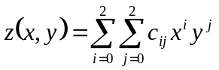, where coefficients 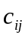 are also set in setup file.
  - surface.leftwall – distance in meters to the left border of calculating area (should correspond to program setups volume.exe);
  - surface.rightwall – distance in meters to the right border of calculating area (should correspond to program setups volume.exe);
  - surface.floor – distance in meters to the bottom border of calculating area (should correspond to program setups volume.exe);
  - surface.const.r – pipe radius in meters, in a case if the parameter surface=const.
- parabolic surface params – section contains definitions of coefficients of parabolic surface, namely:
  - surface.parabolic.n – quantity of parabolas in a cross-section cut;
  - surface.parabolic.a_{i}, surface.parabolic.b_{i}, surface.parabolic.c_{i} – coefficients of the equation z_{i}(x,y)=a_{i}x²+b_{i}x+c_{i};
  - surface.parabolic.W_{i} – width of ‘i’ area in meters in a cross-section cut.
- parabolic3D surface params – section contains definitions of coefficients of parabolic surface, namely:
  - surface.parabolic.c_{ij} – coefficients of the equation.
- fault options – section contains imitation of errors SLM, namely:
  - errorMean – mathematical expectation of errors SLM in meters;
  - errorVariance – the SLM error dispersion (the error by Gaussian distribution);
  - zeroPerCircle – mathematical expectation of zero points quantity (errors when the signal does not come back) during one round of SLM.

Description

After running start_GUI.bat the main window appears as:

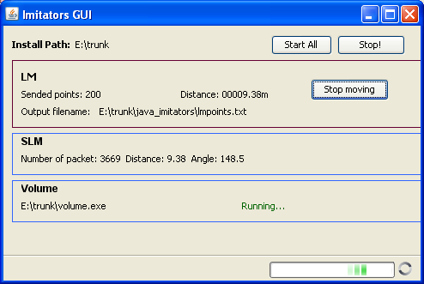

Fig.1. View of the window of the management program

Set of the operating elements:

  - Start All – starts an imitation process for IM imitator, SLM imitator and enables the program volume.exe;
  - Stop – stops all three working processes: IM imitator, SLM imitator and program volume.exe;
  - Start moving/Stop moving - start/stop of IM imitation of longitudinal movement.

Set of information data fields:

  - Install Path – a full path of installation catalogue;
  - Volume – a section of parameters of calculation program volume.exe, which contains a full name of an executable program’s file, and also diagnostic results of the program activity;
  - LM – a section of parameters of IM imitator, namely:
  - Sent points – quantity of the generated readings for imitated longitudinal distance of the scanner;
  - Distance – a current imitated longitudinal distance of the scanner in meters;
  - Output filename – a full name of a file for output generated readings for imitated longitudinal distance of the scanner.
  - SLM – a section of SLM imitator parameters, namely:
  - Number of packet – quantity of network packets with information of generated readings from SLM imitator;
  - Distance – a current imitated distance in meters to a point of imitated surface of stuff in a cross-section cut with current angle of SLM head turn;
  - Angle – a current angle of SLM head turn in degrees.

Preparation

Before the start of IM and SLM imitators it is necessary to set required parameters in setup files into subdirectory java_imitators, for example:

File lm_im.properties:

#LM imitator properties file - lm_im.properties

#--- output properties

#port to recieve queries to get points
udpport = 3095

#file to write points
outputFile = lmpoints.txt

outputToConsole = false
logSpeedPeriod = 2000

#--- imitation properties
speed = 0.1
minDistance = 5
maxDistance = 10

errorVariance = 0.01
errorMean = 0

File slm_im.properties:

#SLM imitator properties file - slm_im.properties

#-- network options –

#Receive packets on port
slmport = 30

#LM imitator ip-address and port
lmip = 127.0.0.1
lmport = 3095

#-- surface options –

#surface type: const, parabolic, parabolic3D
surface = parabolic

surface.leftwall = 15.0
surface.rightwall = 15.0
surface.floor = 12.

#-- parabolic surface params –

# parabolic functions
surface.parabolic.n = 1

surface.parabolic.a1 = 0.01
surface.parabolic.b1 = 0.0
surface.parabolic.c1 = 5.0
surface.parabolic.W1 = 30.0

#-- parabolic3D surface params --

#-- fault options --
#Accidental error of range parameters, error distributed normally
errorMean = 0
errorVariance = 0
#Zero range per circle
zeroPerCircle = 0

Working process and control of results

Working process for the volume calculation program volume.exe and IM и SLM imitators can be considered through an example of inserted above parameters that are simulated by parabolas in cross-section cut of stuff surface. In this case by means of simple preliminary analytical calculations we will find required stuff volume in a calculation area.
The size of a calculation area (the size of a storehouse) is set as:
  - Left = 15 meters;
  - Right = 15 meters;
  - Height = 12 meters;
  - First = 10 meters;
  - Last = 5 meters.
Imitated by parabolas in cross-section cut (surface=parabolic) the elements of surface are setup as:
  - surface.parabolic.n=1 (one parabola);
  - surface.parabolic.a1=0.01;
  - surface.parabolic.b1=0;
  - surface.parabolic.c1=5.0;
  - surface.parabolic.W1=30 meters.
There is the set parabola in cross-section cut on fig. 2.
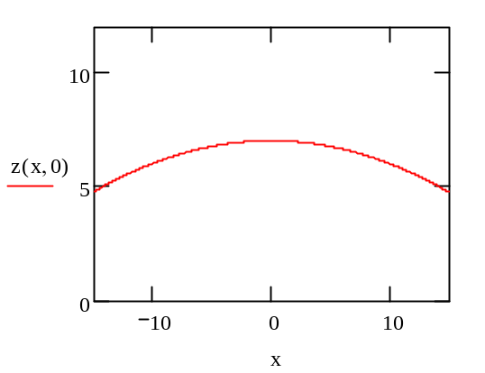
Fig. 2. Parabola in a cross-section cut.

Let’s get volume which the program volume.exe should calculate by analytical method:

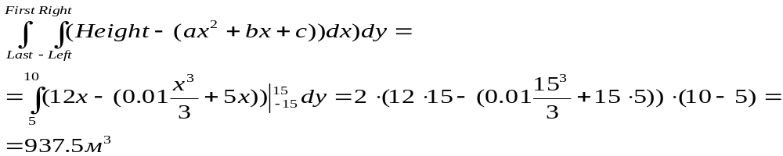

- That to start process of simulated lime volume measuring it is necessary to run a file start_GUI.bat and to click the button Start All. Then the IM, SLM imitators as well as the calculation program volume.exe will be started in absence of an error messages.
- For enabling connection with SLM imitator and to be able to give commands to start the process of imitation of lime surface it is necessary to click the button Scanning in a window of calculation program volume.exe.
- For starting process of IM imitation of longitudinal movement of the scanner it is necessary to click the button Start moving in a window of the management program.
- The IM imitator after getting out from the calculation sets speed of longitudinal movement of the scanner equal to zero, and continues to send current constant value of longitudinal distance.
- To disconnect the SLM imitator it is necessary to click the button Stop in a calculation program window volume.exe.

In case of turning on a rendering mode 2D in program setups volume.exe the graphic top view of a surface imitated by parabolas in a cross-section cut should be the same as on fig. 3.

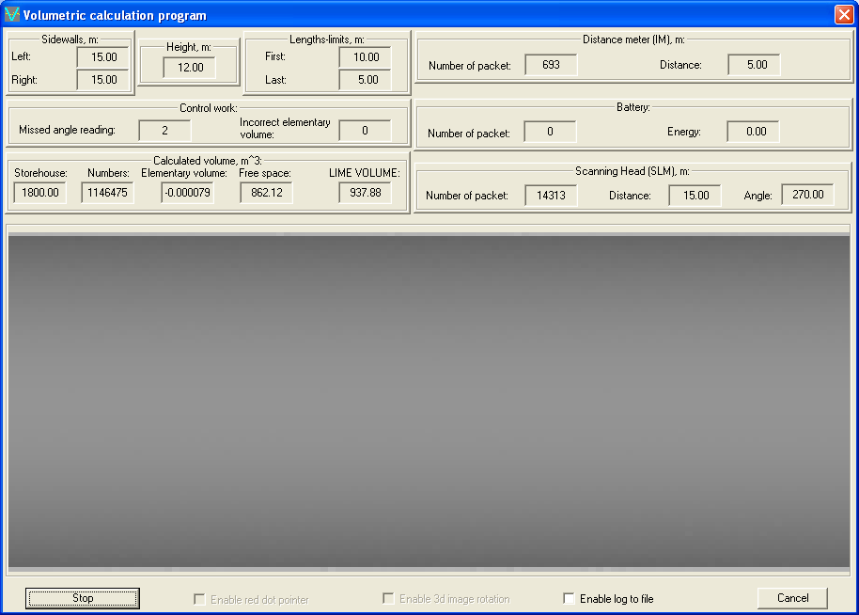

Fig. 3. An example of rendering 2D of surface imitated by parabolas in cross-section cut (top view).

In case of turning on a rendering mode 3D in program setups volume.exe the graphic kind of surface imitated parabolas in cross-section cut should be the same as on fig. 4.
Value in the field LIME VOLUME should accord to analytically calculated value. By difference between these values it is possible to judge a result’s error.
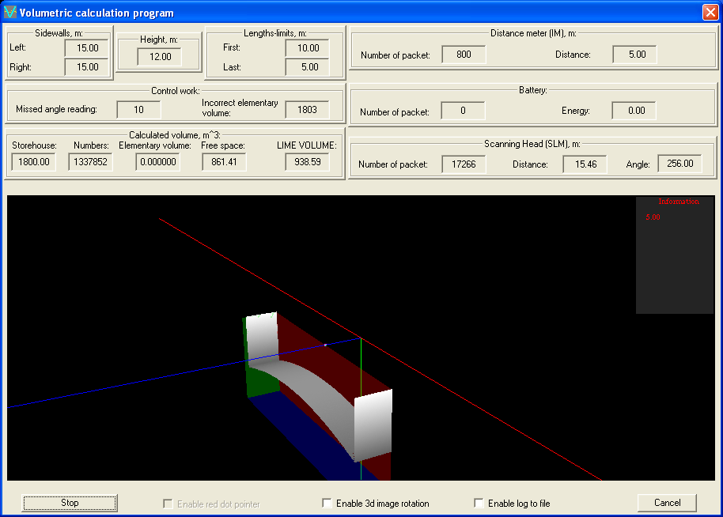

рис. 4. . An example of rendering 3D of surface imitated by parabolas in cross-section cut.

- That to stop working with the volume calculation program volume.exe,IM and SLM imitators it is necessary to click the button Stop in a window of the management program and to close this window.

